
COMPANY PROFILE
&
Hiring of services of Testing Recruiting
Agency to conduct recruitment tests for various vacant positions

M/S Al-Hussaini & Company (Pvt) Ltd

Submitted By
M/SAl-Hussaini & Company (pvt) Ltd.

Head Office: D-3, 4th Floor Amir Chamber, Block-13A, Gulshan-e-Iqbal, Karachi, Sindh, Pakistan
Or, House-74/E, Block-E, Gulshan-e-Jamal Karachi Sindh
Telephone(s): (+92)-21-34688674, 34824210. Fax, 34680660 Cell: (+92) 321-2374426.
Web; www.alhussaini.com.com Email,ahcpvtltd@yahoo.com
Sub Office: Rawalpindi: House No; 313, Street No-2, Munawar, Colony Adyala Road Rawalpindi Cell No-0300-2341043
Sub Office: SHARJAH- UAE: P.O Box; 64128, Sharjah UAE Cell No-00971566400247


List of Head Office & Sub Offices
S.No | Contact Persons | Address | District
01 | Mr. Danish Channa | D-3, 4th Floor Amir Chamber, Block-13A, Gulshan-e-Iqbal, Karachi, Sindh, Pakistan  Or  House No.74/E, Block-E, Gulshan-e-Jamal Karachi Sindh Pakistan | Karachi
02 | Ms Nadia Naz | SHARJAH- UAE: Est. P.O Box; No-64128, Sharjah UAE: Web; www.akarllc.com | Dubai UAE
03 | Ms Shama Firdous | Rawalpindi: House No; 313, Street No-2, Munawar Colony Adyala Road Rawalpindi | Rawalpindi / Islamabad
04 | Mr. M Irfan | House # 481, Street 5, Sector F-7, Phase 6, Hayatabad Peshawar. Peshawar, Khyber Pakhtunkhwa. | Peshawar
05 | Mr. Pitrous Jorge | House No-9, Street No-9, Bogiwal Bagbapura Lahore | Lahore
06 | Mr. Saadullah Dhotani | House # A-47, Near Sunrise Collage  Township Khuzdar Baluchistan | Baluchistan
07 | Mr. Rashid Anes Mangsi | First Floor Post Office Near PSO Petrol Pump Lahori Muhllah Larkana | Larkana
08 | Mr. Jan Mohammad Dal | H/No.B-10 Sachalabad Near Citizen Colony Qasimabad Hyderabad | Hyderabad
09 | Mr. Muhammad Amin Junejo | House No-102, Sachal Street, Sector 1  Town Ship Sukkur | Sukkur
10 | Mr. Mohammad Amir | House 01 First Floor Manthar Road Gousya Pul Rahmat Colony District Rahim yar khan | Rahim yar khan

Name of Company: M/S Al-Hussaini & Company (Pvt) Ltd – (AHCPVTLTD)

SECP Registration: License No: 0078322

ISO Certified ISO – 9001:2015, No: Q-14054/18C

Contact person: Danish Channa (Chairman)

Contact Details: M/s Al-Hussaini & Company (Pvt) Ltd
D-3, 4th Floor, Amir Chamber, Block 13-A, Gulshan-e-Iqbal, Karachi, Sindh, Pakistan
Tele: 92-21-34688674 / 34824210 / 34978281
Fax: 92-21-34680660
Mobile: 0321-2374426 /0301-8380417 /0300-2341043
Email: ahcpvtltd@yahoo.com,
Website: http://www.alhussaini.com.pk

NTN Certificate No: 3953044-2

GST: 3953044-2
Chamber of Commerce Membership No; 115724
Certificate
TAAP Membership No. A00438

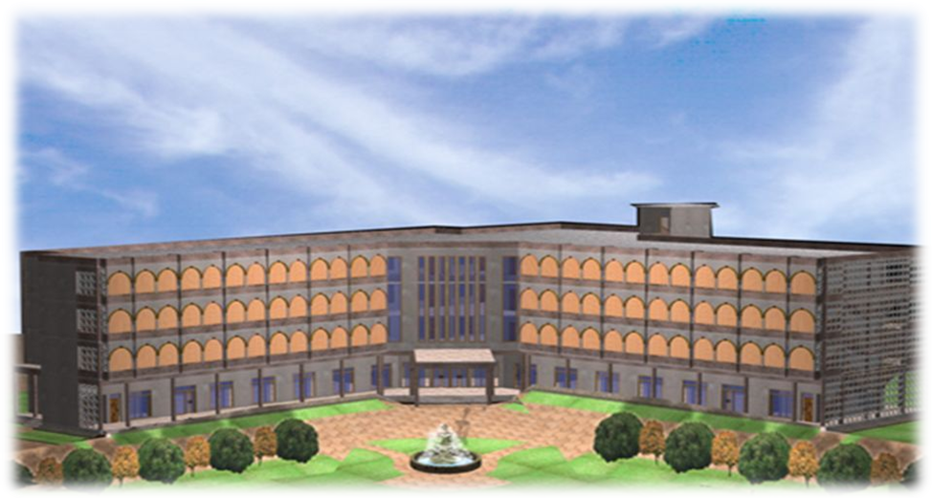
Introduction:

M/s Al-Hussaini & Company (Pvt) Ltd, is a full featured multi-disciplinary firm in human resource, requirement & testing, designing agency, construction and material supply having an experience of more than 16 years providing services in major domains of human resource supply, testing, Architecture, Civil Engineering, Janitorial Services, and Material Supply.

We are in the business of undertaking quality recruitment and testing, construction works, material supply, HR Supply and office janitorial/cleaning service as we possess knowledge and expertise, can ensure guaranteed performance, on competitive pricing. We also provide to all our customers with high quality customer focused services, designs materials with complete dedicated support as we are manned by team of professionals, highly-qualified and professionally experienced in their respective technical and business areas.

We are fully capable and experienced to execute/take over responsibility for services for all given tasks such as recruitment and testing, Human resource supply and management in Janitorial and Cleaning Services, Car Park Operation & Management Services, Plumbing Services, Lift Operating Services, Carpentering Services, Chauffer Services, Kitchen Services, Sports Support & Event Management Services, Office Attendant Services and Cash Sorting Services, Electrical, Mechanical, Civil and Telecommunication Maintenance Services, Architectural Designing and Construction Services.

Al-Hussaini & Company (Pvt) Limited (formerly Al-Hussaini Developers & CO) is in the field of construction since 1999 and it has come to a long way to high engineering national and international importance by meeting symbolize commitment, distinction and professional excellence, stringent, demanding extra ordinary work civil work & General works.

The ever increasing efforts to works attaining better and new business venture have exposed the company to multitude of engineering disciplines now is company’s prerogative to be working in infrastructure, housing, design and environment areas like construction of roads and buildings.

Al – Hussaini and Company boasts and claims to have a reputation of company delivering the projects ahead of schedule. This has consolidated trust and confidence with our business entrepreneurs. The repetition of orders we have been getting from the clients is a touchstone of their reliance in AL-HUSSAINI & company (Pvt) Ltd and clear emblem of the comfort extended by us.

AL-HUSSAINI & Company (Pvt) Ltd. enjoys the reputation of being a trend setter in the ever expanding Behan Benazir Basti, District Badin, Dadu, Mirpur Khas, Benazir Housing Cell Government of Sindh of Housing and infrastructure, Hydrological and Geological survey in Indus delta and many water resources in Pakistan the last years and has earned a respect and reputation of being most recognized name in the market. The biggest name in General Order Supply of development are proud to have AL-HUSSAINI & company (Pvt) Ltd. associated with them, AL-HUSSAINI And company has added value through a useful engineering contribution towards the concept or development of housing and infrastructure vis-à-vis other disciplines.

AL-HUSSAINI & Company (Pvt) Ltd. having thrown its weight abroad has been successful in maintaining the balance and secure job of high engineering practice and financial value.

Today we stand tall and firm over the strong foundation of reputation and trust with a high value and numbers of human resources which given us a distinctive edge over the competition in the market.

Mission:

Our vision is to be the Pakistan’s preeminent designer/builder of unique, architectural memorial structures and be a provider of quality services in major domains of Recruitment & Testing Services, Quality HR provider and Manager, Janitorial Services, Architecture, Civil Engineering and material supply.





The AL-HUSSAINI & COMPANY (PVT) Ltd. alliances with its customers to ensure their complete satisfaction through provision of quality services in major domains of Construction developers, Recruitment and testing, human resource provider and manager, Janitorial Services, Architecture, Civil Engineering and material supply experience. This not only means that AL-HUSSAINI & COMPANY (PVT) Ltd. will deliver a high quality product on time, within the required deadlines and within the agreed budget and rates, so that customers have complete confidence and peace of mind throughout the process of their association and working with AL-HUSSAINI & COMPANY (PVT) Ltd. Keeping in view that all risks have been managed and all reasonable contingencies planned for.

AL-HUSSAINI & COMPANY (PVT) Ltd. values integrity; our practices are honest, our conduct is legal and ethical. Although we are motivated by a fair return on our investment, we are always striving for win-win partnerships with customers who share our desire to design and build memorial structures that add value to the communities in which they are built and assist cemetery owners in keeping the promise of perpetuity that they have made to their lot holders.

To this end, we are committed to effectively communicating to our customers the benefits of AL-HUSSAINI & COMPANY (PVT) Ltd. while ensuring that our customers receive real and measurable value from our 30-plus years of experience working with Private & Government Sectors from all over Pakistan and abroad.

Our employees are our most important resource in achieving our mission. At AL-HUSSAINI & COMPANY (PVT) Ltd. We focus on recruiting, developing and retaining employees with the skills and competencies required to maintain a dynamic corporate culture driven by the values of quality, innovation and safety. We then provide our people with the most effective tools and technologies required to further ensure our customers are completely satisfied with every stage of their working partnership with AL-HUSSAINI & COMPANY (PVT) Ltd.

We hope and believe that this path will lead to excellence, to innovation, to adventure, and to the kind of uncertain, gutsy leadership that will allow both our employees and our clients to realize their aspirations at least - and maybe a lot more.
Our objective is to achieve a high standing for Al-Hussaini and Company and be an undisputed leader as a provider of quality services in major domains of National Testing Services, Human Resource management, Event Management, Construction and Designing, Architecture & Janitorial Services.
Our Objective
Services of National Testing, HR Management, Civil Engineering and material supply that provides solutions and services with highest level of Professionalism while ensuring a profitable growth for ourselves.



Firm

M/s Al-Hussaini & Company (Pvt) Ltd, is a full featured multi-disciplinary in Human resource providing and management, Requirement & Testing, Designing, Construction and Material supply firm having an experience of more than 16 years providing services in major domains of National Testing Services, HR management, Janitorial Services, Architecture, Civil Engineering and material supply that strives to create sustainable & environment friendly architectures that look and feel beautiful.

We are fully capable and experienced to execute/take over responsibility for services for all given tasks such as Recruitment and testing, HR Management, Chauffer Services, Kitchen Services, Sports & Event Management Services, Office Attendant Services, Cash Sorting Services, Janitorial and Cleaning Services, Car Park Operation & Management Services, Electrical, Mechanical, Civil and Telecommunication Maintenance Services and Architectural Designing and Construction Services, , Plumbing Services, Lift Operating Services, Carpentering Services.

We are in the business of providing quality services as we possess knowledge and expertise, can ensure guaranteed performance, on competitive pricing. We also provide to all our customers with high quality customer focused services, designs materials with complete dedicated support as we are manned by team of professionals, highly-qualified and professionally experienced in their respective technical and business areas

All services are provided by the highly qualified, experienced and dedicated professionals who are licensed, experienced and committed to clients ensuring dedication, continuity and satisfaction. This dynamic team of individuals with the experience and talent provide our clients with customized, creative, sensible and responsive client-appropriate satisfaction.

Major Domains of Operation

Our firm is capable to execute / take over responsibility for services for all of given tasks as under:

- Carrying out screening/skill test as per services rules/recruitment
- Recruitment & Testing Service as per employer specification
- Manpower Provider / Technical Staff
- Airport Passenger Facilitation and Handling Services
- Commercial Cleaning and Janitorial Services
- Architecture
- Civil Engineering
- Interior Designing
- Surveying
- Design Approach
- Electrical, Mechanical, Civil and Telecommunication maintenance Services.
- Plumbing services
- Lift operating services
- Carpentering services
- Chauffer services
- Catering services
- Sport support services
- Office attendant services
- Cash sorting services
Expertise and Services

Strategic Planning
With strategic planning, business owners look at both the needs of the business as well as the specific skills that different employees bring to the workplace. The key is to schedule workers so that people are at work when their skills are needed. This is not as easy as it sounds, especially for a small business with few employees. Instead of hiring more workers, which may not be possible, those who use strategic planning methods for assigning manpower often find that multi skilled workers are the most valuable, and therefore may invest in additional training. At the same time, a good strategic boss will not overscheduled an individual employee; that could lead to burnout and the loss of the employee.

Recruitment and Testing

Al Hussaini & Company contracts with public departments across the country to provide professional test administration services. We provide access to lists of prescreened candidates ready for further processing and employment consideration. Our services are guaranteed to save our clients time and money. Al Hussaini & Co is operated by professional testing experts who have worked with thousands of public & non public departments. This experience and expertise has helped to shape an efficient and cost effective recruitment and testing process for departments and candidates. Al Hussani & company’s’ flexibility can accommodate any testing model or civil service requirement and provide candidates with easy access to testing.

Al Hussani & Co Services
- Advertise the vacancy adequately as per requirements of employer using all available print, digital and online sources.
- Design application forms, Test documents and Interviews as per requirement of employer and vacancy.
- Recruits Candidates, Schedules Test Dates and Collects Background Information
- Conduct of tests Continuously in Professional manners at pre designated Centers
- Candidate Scores and Applications are Instantly Available to employers
- Availability of helpline for guidance and assistance to candidates

Trying to find suitable candidates for job vacancies can be a tricky process, especially if a specific job requires a niche mix of skills. For busy employers/companies, the meticulous search and selection of candidates can exhaust a lot of time and resources. Therefore, a lot of companies will hire recruitment agencies to do the job for them. This saves a lot of time and hassle for the company, and lets them get on with other things.

Al Hussaini & Co (Pvt) Ltd provide a ‘search and selection’ service do, well, exactly what they say they do. If a company needs a job opportunity filled urgently, then Al Hussaini & Co will search for the best candidates and select the best people to submit to the employer. We not only use the traditional ways of recruiting and testing by conventional advertisement and written test coupled with various other screening tests and process followed by interviews and medical examination but also keeping in view the emerging technology and needs of the time Al hussaini & Co is taking more responsibility in resourcing, it is essential to get to grips with the myriad recruiting channels, tools and technologies that have emerged in recent years. Although areas such as social and mobile recruiting are still subject to considerable hype, they are growing in importance and HR needs to assess where their true value lies. Today everyone can be found somewhere on the web; the challenge is what to do next. “There is already a plethora of social recruiting tools to find people quickly – that is not the problem, the problem is how to best communicate, contact and engage with the people you find in a time-effective way.”

With so many channels available, Al Hussaini & Co not only identify which are best for their clients’ needs but also find ways to use them efficiently and effectively. Similarly, areas such as video-interviewing and gamification offer potential to improve recruiting practices. When it comes to the mobile space, organizations will need properly thought-through and coherent strategies that will deliver exceptional candidate experience. Our professionals are conversent with using and developing different modules for making our client more comfatable and address all needs for effective and efficient recruiting and testing process. This includes,

- Applicant tracking systems (ATS)
- Mobile recruiting tools
- Gamification
- Collaborative tools
- Location technology
- Video interviewing
- Internet sourcing

Human Resource Supply & Management

Human Resource Management is central to any organization, and it’s about far more than just hiring and firing employees. In forward-thinking companies today, Human Resource Management focuses on the recruitment, direction, and management of human assets, and making strategic plans for the future. Strong Human Resource Management nurtures human talent so employees can become even more valuable to the business.

More than ever before, strategy and planning are integral to successful staffing and support of long-term organizational goals. The responsibility of human resource management continues to grow in complexity and importance for all organizations because of its impact both on culture and business strategy. Professionals at Al Hussaini & Companay encompasses many aspects like training, employee relations, payroll, benefits, compensation, safety, legal, communication, engagement, and more. But the main function now is as a partner in driving strategy from a legal, ethical, and long-term planning perspective.



Shifting labor market conditions and new ways of doing business call for Human Resource Management business strategies that include recruiting and retaining the right people, as well as providing ethical and cultural leadership. The skill sets needed in digital advertising are constantly changing. Al Hussaini & Co think strategically about the talent we need today and tomorrow to win major contracts in a highly competitive job market.
Keeping in view all, Al Hussaini & Co not only provide originations with professional manpower in skilled and non-skilled areas to undertake the task in highly professional atmosphere but also manage the same with our highly skilled and professional teams in every area of specialties as the ability to plan for the right workforce has never been more critical or more difficult than today. Technology, communications, and an accelerated rate of change mean that companies and their human resources arm need to be open-minded, nimble, and ready to make the shifts that will keep them competitive and same is ensured and granted by Al Hussani & Co (Pvt) Ltd.
Airport Passenger Facilitation Services

Al-Hussaini & Company (Pvt) Ltd understands that passenger facilitation services is a series of processes, designed to make the journey through an airport as smooth as is possible which begins as soon as a passenger buys the ticket. Customer service is one component of this. Airports strive to make their customers’ experience of the airport a pleasant one and Al-Hussaini & Company (Pvt) Ltd passenger facilitation services complement and supplement their efforts to do this.

The vision of Al-Hussaini & Company (Pvt) Ltd passenger facilitation services is to provide the passengers travelling by an airline with an end-to-end experience that is seamless secure and efficient so that they enjoy a smooth comfortable, and undisrupted journey.



Al-Hussaini & Company (Pvt) Ltd passenger facilitation services address specific operational and technical passenger facilitation issues, such as way-finding, baggage sorting equipment, inter-modality solutions and more.
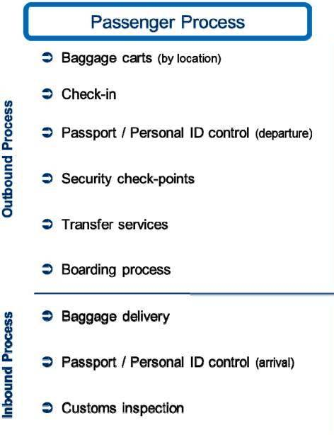

The activities of Al-Hussaini & Company (Pvt) Ltd passenger facilitation services staff are designed to focus on efficient management of the flow of passengers, baggage, cargo and mail through the airport facilities, ensuring that services are delivered in a healthy, safe and secure environment, and meeting and exceeding when possible the needs and expectations of customers. This is applicable for all scenarios, during good days and bad days, under normal operations and situations of flight disruption.



Passenger facilitation is not just achieved by Al-Hussaini & Company (Pvt) Ltd passenger facilitation services staff in isolation but through a high level of interaction and coordination with partners and stakeholders that are responsible for the different steps of the end to end passenger process, from the time of booking to the time the passengers arrive at their final destination.

Al-Hussaini & Company (Pvt) Ltd provide educated, well groomed and trained staff that has excellent inter-personal and communication skills for passenger facilitation services. The staff who will be fluent in speaking and understanding English besides local lingua franca will be trained in how to integrate the airport’s mission/vision, master plan, airport brand and customer service delivery, and create the necessary alignment between all essential players (airport operator and the entire airport community) to achieve excellent results. These include enhanced customer experiences, improved customer satisfaction, a more positive airport image, stakeholder involvement and buy-in, and increased net revenues.

The check-in is normally handled by an airline itself and will be facilitated by the Al-Hussaini & Company (Pvt) Ltd passenger facilitation services staff working on behalf of CAA. Passengers usually hand over any baggage that they do not wish or are not allowed to carry on to the aircraft's cabin and receive a boarding pass before they can proceed to board their aircraft.

Check-in is usually the first procedure for a passenger when arriving at an airport, as airline regulations require passengers to check in by certain times prior to the departure of a flight. This duration spans from 2- 3 hours depending on the destination and airline. During this process, the passenger will be facilitated in terms of special accommodations such as seating preferences, information about the flight or destination, assisted in making any changes to reservations if required, for accumulation of frequent flyer program miles, or paying for upgrades and excess baggage.

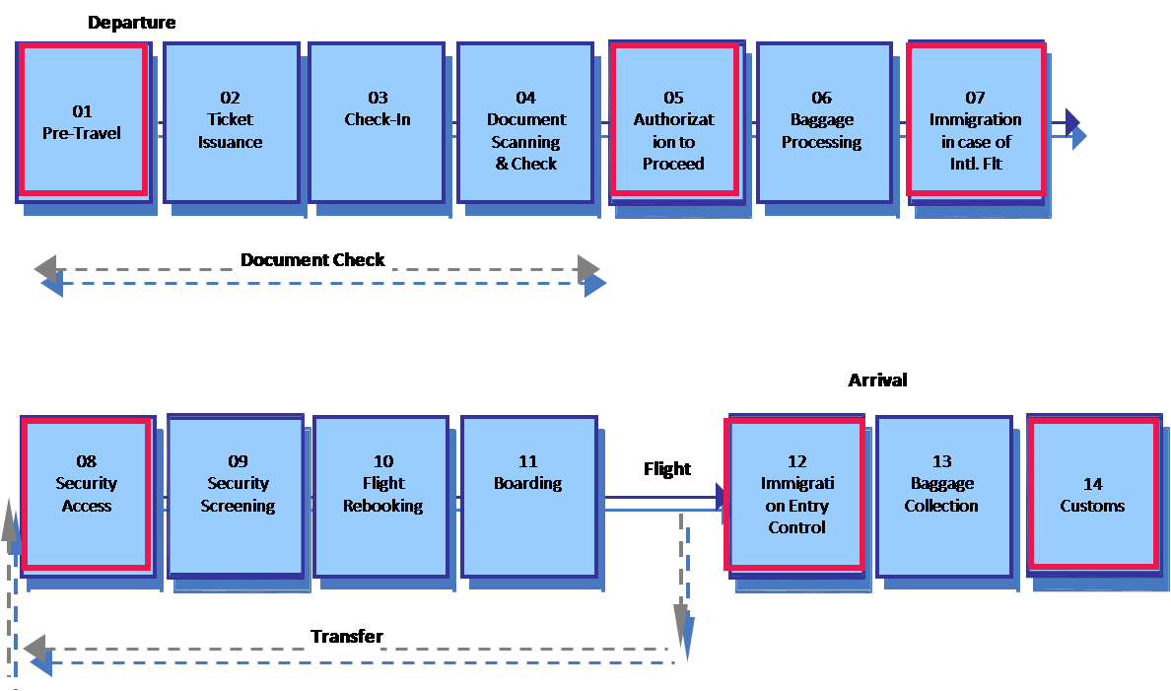

The airline check-in's main function, however, is to accept luggage that is to go in the aircraft's cargo hold and issue boarding passes and passengers will be facilitated in this process. VIPs, elderly, sick and disabled will given special handling

In case of transfer passengers check-in options and procedures vary per airline with some airlines allowing certain restrictions which other airlines have in place, and occasionally the same airline at two separate airports have different check-in procedures. Such differences are usually not noted by the average passenger and occasionally lead to service interruptions when one carrier refuses to abide by the procedure that another carrier normally would be willing to do and such passengers will also be facilitated so that they may continue their journey smoothly and without disruption.

Al-Hussaini & Company (Pvt) Ltd passenger facilitation services will deploy 30 staff comprising male and females who will be deployed as per need and requirement in VIP, Departure and Arrival areas to help out the incoming and outgoing passengers. Beautiful and attractive kiosks of “May I Help” will placed in designated areas as selected by CAA who will be manned by these staff in three daily duty shifts seven days a week.

Architecture

Al-Hussaini & Company (Pvt) Ltd Engineering Firm’s diversity of experience allows the firm to address the unique goals of each client. Our architectural professionals serve clients in corporate, educational, healthcare, hospitality, real estate development and public sectors. We provide design solutions that are site responsive, constructible, innovative and environmentally conscious. Our teams manage projects from start to finish, including Programming / Conceptual Design, Schematic Design, Design Development, Construction Documents, Bidding / Negotiation, Construction Administration and Post Construction Reviews.

- Site Evaluation
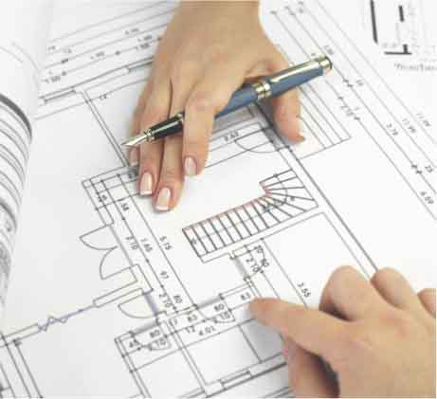
- Feasibility Studies
- Planning and Zoning Research/Consultation
- Project Scheduling
- Programming
- Code Reviews
- Life Cycle Analysis/Value Engineering
- Historic Preservation/Restoration
- Renovation & Reuse Projects
- Construction Administration & Inspections
- Roofing, Drainage, Insulation Upgrades & Replacements
- Barrier-Free Design & Renovations

Civil Engineering


Al-Hussaini & Company (Pvt) Ltd Engineering takes pride in its ability to create team approaches that successfully address clients’ diverse engineering challenges. Our firm brings together extensive engineering skills and responsive service to meet demanding schedules and budgets. Our qualified staff and strategic design approach helps expedite the agency submission process, which helps clients achieve timely approvals and allows construction to begin sooner.

- Site Planning
- Water Facilities
- Wastewater System Analysis & Design
- Storm water Management
- Erosion & Sediment Control Plans
- Roadway & Parking Lot Design
- Subdivision Design
- Flood Plain Studies
- Drainage Systems Evaluation & Design
- Traffic Impact Studies

Interior Designing

Al-Hussaini & Company (Pvt) Ltd interior design studios provide services both in support of the firm’s architectural department and independently. Our teams have worked with clients in the corporate, educational, healthcare, hospitality, municipal and real estate markets. We strive to incorporate environmentally conscious solutions through the use of products that enhance indoor air quality, increase the use of natural light, and use recycled or recyclable materials to create sustainable “green” environments. Our interior design staff provides solutions for ergonomic, functional and efficient spaces that meet the aesthetic goals of our clients.


- Pre-Design Planning / Programming
- Furniture Inventory
- Space Planning / Interior Architecture
- Finish Selection & Specification
- Custom Casework & Floor Patterns
- Furniture, Fixture & Equipment Specification
- Furniture Bidding & Negotiating
- Construction Observation & Furniture Installation / Coordination
- Move Coordination
- Artwork & Accessory

Surveying

Surveying is the first step to a successful project! Utilizing cutting edge surveying equipment, including the latest GPS and Robotic Survey Systems, AL Al-Hussaini & Company (Pvt) Ltd engineering firm survey crews provide all forms of site data from which to design, engineer and build projects. These tools allow our crews to respond efficiently to meet demanding schedules. Our professional survey crews can provide:-

- ALTA / ACSM Surveys
- Boundary, Topographic & Aerial Control Surveys
- Construction Stakeout
- Mapping / GIS Data

Design Approach

We lead design teams in the pursuit of place-specific, high-performance designs. Our collaborative design approach begins with a detailed analysis of each site, program and community, identifying the economic, environmental and social forces that will give form to the design solution. We then synthesize these unique characteristics with broader criteria for habitat creation, watershed protection, mobility, energy production, material health and recapture, and indoor environmental quality.

For each project, we create a design framework built upon clearly articulated principles (what is valued), short, medium and long-range goals (what projects hope to accomplish), and specific design strategies (how goals will be achieved). This framework establishes the project’s direction and serves as a reference point throughout the building’s lifespan—it establishes priorities and focus by asking the right questions at the right time.

Our design teams begin with our clients and their communities and extend to the multidisciplinary consultants with whom we collaborate from the earliest stages of the project. We foster a team dynamic that gives everyone a voice while providing the right expertise at key decision points. Working around the world, we use the latest technologies to facilitate frequent and effective communication with each project team.

Electrical, Mechanical, Civil & Telecommunication Maintenance Services


In this section we will fulfill all the requirements of user like as Checking maintaining & ensuring smooth power supply to all equipment’s all electric Distribution Boards, Wiring, Fitting & equipment’s and remove defects on the spot ensuring smooth & uninterrupted power supply Checking, , fire alarm/fire hydrant system, security alarm system, UPS, CCTV system, Computers, Lifts, Air-conditioners, Telephone Exchange, FM-200 Fire Suppression System at IT Group, Water
Dispensers etc. Sort out and removal of fault, loading balance. Replacement of defective electrical components i.e. Tube Rods, Bulbs, Energy Savers, Chokes, Starters, faulty or short circuited points/ wiring etc, Maintenance of all earthling systems electrical panels and motor starters of water turbines/pumping sets, distribution boards / sub-main panels normal/emergency & generator panels . Operations of all pumping sets, office Generators, smoke & heat detectors, PF Panels. Maintenance & repairing of telecom system of PABX & LAN cabling & direct PTC/NTC lines, Data & Telephone cables/sockets/outlets etc


Plumbing Services

In this our task force will be responsible for all plumbing issues .They catered for Maintenance & servicing of sanitary fittings General fitting, repair of G.I/PVC water supply & sewage conduits /pipes I/C, Sui gas G.I lines water pumping sets/turbines, replacement of gain packing, greasing, cleaning Etc . A general maintenance of underground and overhead water tanks, water/gas supply lines, valves burners/fittings of burners, water coolers, water filters etc has also be worked out.
Lift Operating Services

A well-qualified team will be established for lift operating system and its services. They will ensure operation as per Standard Operating Procedures, like as per capacity, segregated lifts for executives/non T executives, male/female segregation. They will also be responsible for Observing precautions against electricity failure and emergency measures to coup with the emergencies and ensuring non-use of lifts for cargo purposes and maintenance of cleanliness in lifts.

Carpentering Services

A well-qualified team will be established for Repair and replacement of all type of office furniture i.e. Cupboards, cabinets, wooden partitions, doors & windows locks, door closers of wooden packing around air-conditioners etc.

Chauffeur Services

Chauffer services will be provided as per authorize scale and user requirement. Like Performing of Bank’s general chauffer services, for official guests, Government delegations, Organization high officials. They also perform the duties for keep the official cars’ exterior & interior neat and clean & for timely Oil Change.

Catering Services

A well maintained and highly hygienic kitchen services will be facilitated and where all quality standards are adopted. Here will be provision of some below mentioned:-

- Provision of Cooking Services in official kitchens/Canteens/cafeteria of the Bank within designated hours and specified time.
- Cooking of various dishes for office lunch by experienced cooks.
- Serving of lunch, drinking water & replenishment at dining tables.

Cooking & serving of desserts.
- Cleaning, Washing & preparation of cooking material.
- Preparation & serving of salad.
- Cooking & Serving of meal for official functions.
- Washing, drying and placing of all type of crockery.
- Maintaining record of all crockery & table wears.
- Maintaining cleanliness in & around the kitchen through mopping & washing etc. and keeping the kitchen, dining hall free of pests, rats, flies & mosquitoes by spraying insect killer etc.

Sports Support Services

Sport Support facility is provided as per a user requirement which meets all the standard procedure. In which training & coaching services for the members through skilled and experienced personnel, Maintenance of all type of sports machinery, equipment, swimming pool, gymnasium machinery & equipment’s Provision and maintaining of Catering Services for members of the Sports Club.

Office Attendant Services

A well-mannered and highly reputable team will be available for attendant services. They will responsible for Preparation & serving of tea/cookies for staff members & official guests/Customers Washing, drying and placing of all type of crockery at proper place Serving of lunch, drinking water & replenishment at dining tables. They are also performing the duties for Dusting of files & office equipment’s Perform messenger Services Picking and Delivery of local mail.

Cash Sorting Services

A well-mannered and educated team will be available for Cash sorting. They will act on all the instructions and advise of organization. and they will also responsible for their respective jobs.

Janitorial Services

Al-Hussiani & Company (Pvt) Ltd is in the business of providing quality office cleaning service, and we take pride in upholding our sterling reputation. With our knowledge and expertise, performance guarantee and competitive pricing, AHCPVTLTD is your best maintenance choice.



We take this opportunity to introduce our company “Super Cleaners”. We are serving our valuable clients whose list is attach since 2008. Our proffesionals are highly qualified and serve as Laundry Manager and Executive Housekeeper in top hotels of city such as west bestrewn Hotel and others Departments of Government of Pakistan. We also provide janitorial services with professionalism at Airports, Hospitals, Universities and other organizations. We provide highly trained staff with ultra-modern techniques and sophisticated equipment for Janitorial services on Daily, Weekly, Monthly and Yearly basis, which includes:-
- Regular janitorial commercial office cleaning
- Carpet cleaning
- Hard surface floor care – scrubbing, stripping, waxing, buffing, polishing and sealing
- Concrete floor scrubbing, cleaning and sealing
- Window cleaning
- Supply management/inventory co

Environmentally Responsible

AL-HUSSAINI & Company (Pvt) Ltd is an environmentally responsible company where we value the health and wellness of our clients and employees – we are committed to the utmost environmental standards for cleaning, and janitorial services. We use only environmentally friendly janitorial products and supplies partnered with eco-friendly, energy efficient janitorial equipment, so as to keep our clients’ work place clean and safe from allergens and toxins.

Sustainability & Environment

While design excellence through collaboration is always our goal, the development of green solutions for our clients and our planet is also a priority. We believe each project should be designed for the betterment of the community and society as a whole, and sustainability and green design are a natural extension of our core ideologies.
AL-HUSSAINI & COMPANY (PVT) Ltd feels that sustainability is a commitment to the ideas of creating a better environment at all scales: value to the owner/client, the stewardship of our planet, the health of our population and particularly those who use the project, the vitality of our neighborhoods, the teaching points of the building we place on the site, and the enjoyment the project can bring to its occupants and visitors.

Quality of Work

We are not satisfied with our services unless you are! To guarantee the highest level of service, we utilize Quality Control programs which include onsite inspections and customer surveys. We constantly monitor our work and should any area fail to meet our strict service standards, it is corrected immediately. And of course, we always encourage customer communication and use your input to heighten our level of cleaning services

- All labor will be performed by our courteous, and professionally trained manpower
- All uniforms will be stitched according to specifications on modern equipment and sewing machines
- Full insurance coverage and bonding
- State of the art equipment for fast and thorough cleaning
- Janitorial products that get any job clean

Detail of Monitoring Services

Upon Award of contract, a management team will be deputed immediately and this team headed by Project Manager and qualified / experienced personnel will make further investigation and make a lay out keeping in view of site / work place. They also work out on a practical and monitoring organization design with all resource requirements. Mobilization of personnel and equipment will be carried out immediately as required under the contract agreement and as per requirement. Key temporary facilities including all scope of work and auxiliary facilities will be set up and preparatory will be completed in the shortest time to ensure the commencement of project as specified.

Mobilization of technical / Professional personnel’s is initially planned to be carried out in two stages. At the first stage, some persons shall arrive at site and within short notice other required more persons will move at site, Most of the equipment will be company owned and some of them will be rented locally or purchased.

Monitoring Organization will be finalized and a Project Management Office will be established immediately at site. The head of monitoring team will be Project Manager (PM) for all the activities. Under the leadership of PM there will be skilled functional staff, Engineer and a complete Team etc.

Business Relations

List of Ongoing & Completed projects is attached as Appendix ‘A’ to this document

Capacity & Strength

List of company Staff is attached as Appendix ‘B’ to this documents
List of company Staff is attached as Appendix ‘C’ to this documents

Financial Capacity

Audit reports attached

System of Accounting

AHCPL uses the accruals accounting system which involves “Double Entry” book keeping and refers to the dual aspects of recording financial transaction to recognize that there are always two parties involved: the giver and receiver. The dual aspects are referred to as debits and credits. To assure the transparency in the accounts AHCPL is using well known Financial Software known as “Faryad Ejaz Financials”. This accounting software is operational at Head Office level and at all the provincial offices as well. This software can produce monthly, quarterly and yearly Financial Reports. AHCPL has developed its own chart of accounts so that all the expenses are booked under the proper head of account and financial statement show a true and fair view to its readers. The internal control system for all the financial transaction has been made to ensure proper monitoring of the funds and transparency. The following are the salient features of the financial Management at AHCPL:-

- All the payments are made after proper entry in the accounting software.
- All the payments are made after signing of electronically printed payment vouchers. To ensure proper utilization of funds there are different authorities involved in the approval of a single voucher.
- All payments are made through banking channels including salaries, procurement and other third party payment.
- By recognizing financial obligations when they occur, not when they are paid or received, this overcomes the problem of time lags, giving a truer picture of the financial position.
- The system can deal with the all types of transaction and adjustments.
- The system automatically builds in up-to-date information on assets and liabilities.

These records provide an income and expenditure account summarizing all income and expenditure committed during a given period; and a Balance Sheet which demonstrates, amongst other things, moneys owed to and by the organization on the last day of the period.

As organization is of corporate states hence the legal requirement for corporate as well as taxation laws are applicable. Accordingly, the accounting and financial system has been designed to fulfill requirements of relevant laws applicable in Pakistan as well as the specific requirement of donors.

Banking Transactions

A separate bank account is maintained for each project/ donor. All the bank accounts are reconciled on monthly basis. The bank reconciliation statement are prepared by the Finance Assistant and verified by the General Manger Finance. Quarterly Funds statement are being prepared and shared with the Chief Executive Officer (CEO) to give him a close look on the liquidity position of the organization.

Budgeting

At AHCPL, the budget is essential to plan a project, to fund raise for resources and implement a project accurately. Essentially we do the following three budgets:-

- The income and expenditure budget.
- The capital investment budget.
- Cash flow forecast budget.

Budgeting is done by the National Manager Finance in consultation with the provincial managers and under the guidance of Executive Director.

Budget are reviewed periodically in order to update/ redesigned/ reallocate, if required, to meet the changing needs and circumstances of program implementation in consultation with the donor, if required by the contractual obligation. Provision of the budget is made of staff’s welfare through group insurance for the health management including, hospitalization facility.

Audit
AHCPL has well defined internal control procedures and policies and Finance Department visits the Sub office to check the effective implementation of all the procedures and policies of internal control. Therefore, finance department of AHCPL performs the duties of internal auditor and review the internal control policies, procedures, and checks that these are being properly implemented. A report is presented to the management and if needed corrective action or perhaps changing a procedure, or training a staff member is done.
The external audit is conducted by an independent Chartered Accountant firm, as per the statutory requirements and in accordance with contractual requirements of the donor/ fund provider. The report submitted by the auditor is shared with the Bod and donors.

Accounting and financial management at field level operations with partners

To build local capacity and benefits from local organization in project areas, AHCPL sub-contracts organization for provision of quality services. In such armaments is accountable to the donor/funds provider and to ensure accurate accounting and transparency the following process is deployed:-

- The organization must open a separate bank account for the project.
- Timely disbursement of funds to ensure efficient, effective and uninterrupted service delivery.
- The organization will employ sufficient and appropriate staff as to ensure the segregation of duties, correctness and completeness of accounting transitions recorded.
- To monitor and have arrangements with organization for internal audit to ensure that funds disabled to them are being utilized in services and only on agreed budgets.
- The partner organization will provide the monthly financial statements along with the monthly technical reports and outputs.
MANAGEMENT / DIRECTORS
Sl. No | Name | Designation
 | Mr. Danish Channa | Chairman
 | Ms Nadia Naz | Co Chairman
 | Imran Manzoor Gill, Sqn Ldr (Ret) | CEO
 | Dr Suliman Otho | Director Tech
 | Mr. Zain ul Abidin | Director finance
 | Engr Waqar Ahmed Khan | Director Operation
 | Ms Rubab Khan | Director HR

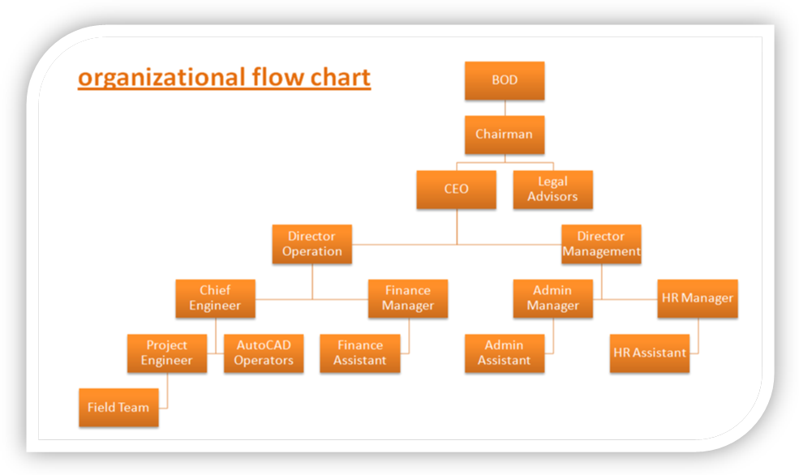
Organizational Chart

Contact Person: | Danish Channa
Designation | Chairman
Organization | Al-Hussaini & Company (Pvt.) Limited  House # D-3, 4th Floor Amir Chamber, Block-13A, Gulshan-e-Iqbal, Karachi, Sindh, Pakistan.
Contact | +92-(21)-34688674, 34824210, Fax 021-34680660  +92-(321)-2374426 / 0301-8380417/ 03002341043  Email: ahcpvtltd@yahoo.com  Website: http://www.alhussainipvt.com
Al-Hussaini & Co (Pvt)Ltd.
Recruitment & Testing / Manpower Services / Technical & Unskilled Labour & Janitorial Service Provider & Innovation in Engineering & Designing / Architecture &Construction

