# C:\Users\MUGHAL~1\AppData\Local\Temp\AHC LOGO.jpgC:\Users\MUGHAL~1\AppData\Local\Temp\AHC LOGO.jpg

# https://aeo.com.pk/wp-content/uploads/2019/02/Ielts-CD-test.jpgComputer-Delivered (CD) IELTS in Pakistan –Expectations vs Reality

**As we all know, computerized versions of a number of tests have made their successful**

**Launch into the new world, or should I say, into Pakistan. Well, IELTS is no exception. Computer-delivered IELTS is the new talk of the town, and how much you act like you don’t care because computers are what you were born to operate; we know that you’re a bit anxious from the inside. Moreover, the fear of computer-delivered IELTS not being what**

**You might expect it to be is the worst of all.**

**I guess by now I’ve quite certainly made my point, that is, before going ahead and taking the test you need to know what computer-delivered IELTS is actually like in reality. So, what are you waiting for Read on to find out some truths that would help you get better prepared for your big test day. Following are some common misconception or expectations, and their realities:**

**CD IELTS is Different from the Paper-Based IELTS**

**While most of the people out there might tell you that computer-delivered tests have a different structure or way of assessment, it’s not the truth. Computer-delivered IELTS is actually very similar to paper-based IELTS, except, of course, you give it through your computer. Moreover, only the Listening, Reading, and Writing sections are to be given through the computer. They have the same content as paper-based IELTS, only you have to type instead of writing with a pen. Furthermore, the Speaking section remains the same in computer-based test (one-to-one with an expert IELTS examiner**

**There is a Difference Related to the Level of Difficulty in the CD IELTS Test and Paper-Based Test**

**There is no difference at all in the content of the computer-delivered test and the paper-based test. The questions and way of assessment are the same, it’s not like you’d get MCQs in a computer-delivered test. So, no need to worry, a computer-based test is not more difficult from a paper-based test, and vice versa.**

**The Candidate Needs to Bring His Own Computer**

**The computer system is provided by the test center, as well as all other equipment, such as headphones. So, no need to fret over borrowing your friend’s computer if yours is not working properly.**

**CD-IELTS Exam Can Be Taken Whenever the Candidate Wants To**

**This one is the biggest misconception of all. Let me tell you guys, candidates have to appear at the specified test centers on the specified time for bot computer-delivered and paper-delivered tests.**

**Candidates Are Not Allowed to Change Their Answers or Leave an Answer Blank in Computer-Delivered Test**

**You might think that you can’t change or rewrite your answer once you’ve typed it in a computer delivered test. Well, you’re wrong, because just like in a paper-delivered test, candidates are allowed to both leave an answer blank or to change their answer. Also, the candidates get 2 minutes for reviewing their answers once they’re done with one section.**

**CD IELTS is Cheaper than a Paper Based Test**

**The cost of the IELTS exam is the same for both computer-base and paper-based tests. However, it may vary for different locations around the globe.**

**All confusions clear, and you’re ready to go give your luck a chance at what’s new. Good luck!**

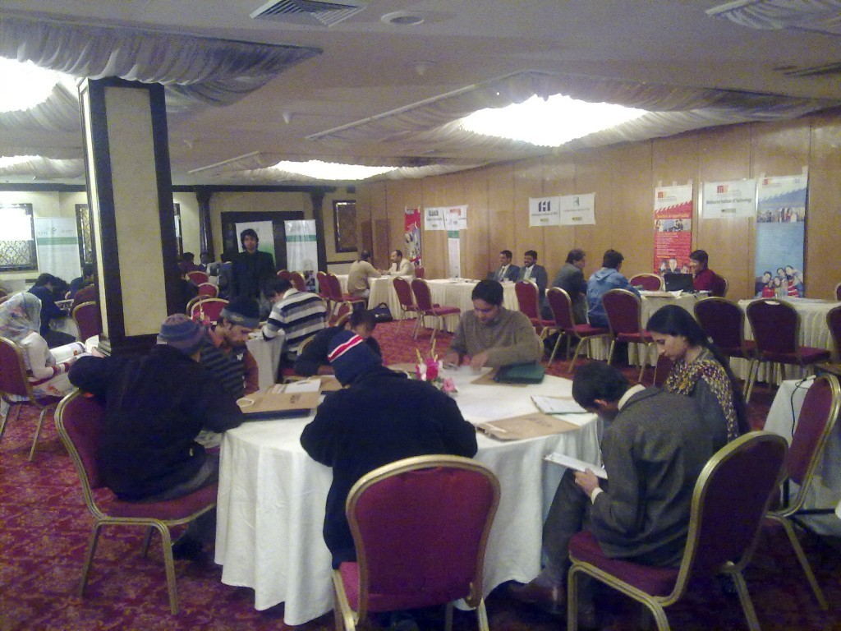**AHCPVTLTD is here to sort out all your problems related to preparing and taking IELTS in a highly competent manner. We have earned a reputable name in the current market by serving the best Testing services / Human Resources Services consultancy services in Pakistan. Contact us as we are 24/7 ready to hear from you.**

## ****Companies****

**Measure what job candidates can actually do  
with work-sample online tests.**

[**START TESTING TODAY**](https://www.testdome.com/pricing)

**Get all Premium tests and questions,run tests from 8 per candidate.**

**Discover a wide selection of tests: programming languages and frameworks, sales, customer service, finance, general aptitude, and much more.**[**View pre-made tests**](https://www.testdome.com/tests)[**Browse the question library**](https://www.testdome.com/questions)

**We have some neat features that make  
vetting candidates much easier, and a dedicated support team to help you get  
the most out of them.**[**Schedule a demo or call with our expert**](https://calendly.com/testdome)[**View TestDome product tour**](https://www.testdome.com/tour)

# C:\Users\MUGHAL~1\AppData\Local\Temp\AHC LOGO.jpgC:\Users\MUGHAL~1\AppData\Local\Temp\AHC LOGO.jpg

**Programming tests focus on a developer's ability to create solutions, implement new functionality, analyze code, or fix a bug.**

# [General Tests](https://www.testdome.com/general-tests)

**General tests range across a broad collection of disciplines, each focused on measuring a candidate's ability to perform a specific skill.**

**Would you like to learn more on how to screen the top talent? Our Evidence-Based Hiring book explains a new and scientific screening process that bases hiring decisions on evidence and data. Step-by-step examples of job ads, questions, tests, and interview scripts will teach you how to remove hidden biases, ask the right questions, and create completely automated screening tests.**

**Create Your Perfect Test**

**Choose one of our**[**predefined tests**](https://www.testdome.com/tests)**for the skills you need or add individual**[**questions**](https://www.testdome.com/questions)**one by one to a new empty test. You can also create your own**[**custom questions**](https://www.testdome.com/tour)**to build a test tailored to your needs.**

**We offer two different question libraries:**

* **The public question library contains common interview questions. You can use these for practicing, or if you want to filter candidates using classic programming problems.**
* **The premium question library contains our unique, hand-crafted questions. We offer a refund if you find any of them answered online.**

**Note: Reselections should test the basic skills, not the total knowledge required. Short tests with 2 or 3 questions are good enough to filter out 90% of candidates. If you are not sure what to test, feel free to**[**ask us for advice**](mailto:support@testdome.com?subject=Testing%20Assistance)**.**

# Invite Candidates

**Save time by inviting all your candidates to a test through one simple interface. Enter their email addresses, choose a deadline, and hit the invite button. Voilà, you are done for the day**

**Test Candidates**

**Candidates that you have invited will receive an email with a link to the online test and instructions for taking the test. We put a lot of effort into making testing a pleasant experience:**

* **Tests can be as short or as long as you want them to be.**
* **Candidates take tests from the comfort of their homes at their convenience.**
* **We allow candidates to use online resources, as that is a normal part of programming.**
* **If candidates prefer, they can copy and paste code into their favorite IDE.**
* **Candidates get feedback about their score (editable in the test settings).**

**Some candidates complain about the lack of time. However, time limits per question give everybody an equal chance and coding speed is important in the real world. The goal is not to score 100%, but to prove that they are better than other candidates.**

# Interview the Best Candidates

**You'll notice that a large portion of candidates will have received a score of 0% at the end of the testing round. This is normal. Unlike school tests, which are designed so that 90% of students will pass, preselection tests usually eliminate 90% of candidates. This is especially true when it comes to programming, where many people have noted that most applicants can't write code at all.**

**All candidates will be sorted and graded into pass and fail groups. You can compare candidate answers and manually adjust the cut-off score. We also provide a feature for you to notify candidates by sending them pass or fail emails. You can use the**[**test report**](https://www.testdome.com/candidate-report-sample)**to ask the candidate for more details during the interview. Good programmers are able to explain their solutions and often have ideas for improvements.**



**A Simple 12 Step Guide to Write an Effective Test Summary Report with Sample Test Summary Report Template:**

**Several documents and reports are being prepared as part of Testing. Some are**[**Test Strategy doc**](https://www.softwaretestinghelp.com/writing-test-strategy-document-template/)**,**[**Test Plan doc**](https://www.softwaretestinghelp.com/test-plan-sample-softwaretesting-and-quality-assurance-templates/)**,**[**Risk management Plan**](https://www.softwaretestinghelp.com/risk-management-during-test-planning-risk-based-testing/)**, Configuration management plan etc. Among these Test Summary Report is one such report which is prepared after the Testing is completed.**

**I have tried to explain the purpose of ‘Test Summary Report’ and provided a sample Test Summary Report template along with an actual report for download.**

**What is a Test Summary Report**

**As we know, Software Testing is an important phase in AHCPVTLTD and also it serves as the “Quality Gate” for the application to pass through and certified as “Can Go Live” by the Testing Team.**

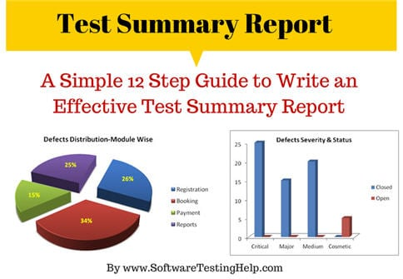

**Test Summary Report is an important deliverable which is prepared at the end of a Testing project, or rather after Testing is completed. The prime objective of this document is to explain various details and activities about the Testing performed for the Project, to the respective stakeholders like Senior Management, Client etc.**

**As part of**[**Daily status reports**](https://www.softwaretestinghelp.com/how-to-write-software-testing-weekly-status-report/)**, daily testing results will be shared with involved stakeholders every day. But Test Summary Report provides a consolidated report on the Testing performed so far for the project**.

***A functionality verification which needs connectivity to a third party application cannot be tested, as the connectivity could not be established due to some technical limitations. This section should be clearly documented; else it will be assumed that Testing covered all areas of the application.***

**a) In Scope  
Functional Testing for the following modules are in Scope of Testing**

* **Registration**
* **Booking**
* **Payment**

**b) Out of Scope  
Performance Testing was not done for this application.**

**c) Items not tested  
Verification of connectivity with the third party system ‘Central repository system’ was not tested, as the connectivity could not be established due to some technical limitations. This can be verified during UAT (User Acceptance Testing) where the connectivity is available or can be established.**

**Step #4: Metrics**

*Metrics will help to understand the test execution results, the status of test cases & defects etc. Required Metrics can be added as necessary. Example: Defect Summary-Severity wise; Defect Distribution-Function/Module wise; Defect Ageing etc.. Charts/Graphs can be attached for better visual representation>*

**a) No. of test cases planned vs executed**  
**b) No. of test cases passed/failed**

[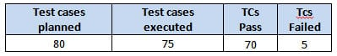](https://cdn.softwaretestinghelp.com/wp-content/qa/uploads/2014/06/test-summary-report-1.jpg)

[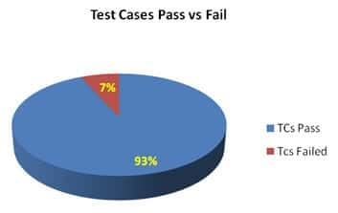](https://cdn.softwaretestinghelp.com/wp-content/qa/uploads/2014/06/test-summary-report-2.jpg)

**c) No of defects identified and their Status & Severity**

[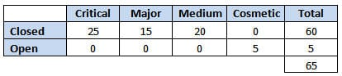](https://cdn.softwaretestinghelp.com/wp-content/qa/uploads/2014/06/test-summary-report-3.jpg)

[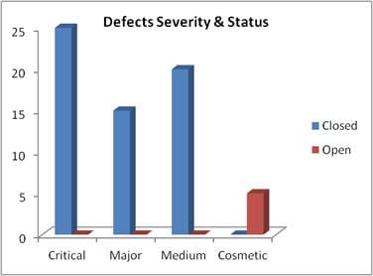](https://cdn.softwaretestinghelp.com/wp-content/qa/uploads/2014/06/test-summary-report-4.jpg)

**d) Defects distribution – module wise**

[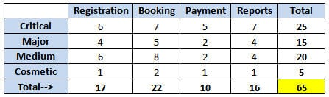](https://cdn.softwaretestinghelp.com/wp-content/qa/uploads/2014/06/test-summary-report-5.jpg)

[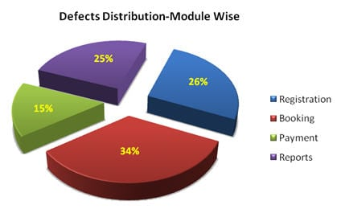](https://cdn.softwaretestinghelp.com/wp-content/qa/uploads/2014/06/test-summary-report-6.jpg)



**A marketing degree is likely to offer a wider range of career opportunities, because it translates well into traditional marketing roles as well as sales, sales operations, and even customer support.**

**If you are looking to climb the corporate ladder, you’re probably best served by this degree since you are exposed to more of the elements that are critical to leadership positions. Marketing is a “top line” discipline that still offers a view into AHCPVTLTD.**

**The downside is that a marketing degree is a pretty common academic credential. A lot of students select this when they aren’t really sure what they want to do. While the degree itself might provide you with very valuable insights, it does not make you incredibly valuable to your employer.**

**Supply chain is more specialized**

**If you enjoy supply chain and/or business operations, this degree will put you far ahead of the game vs. a standard business administration focus. Whereas the marketing and supply chain degrees will both provide you with theory, the application of that theory is more consistent on the supply chain side.**

**Put differently, if I have a marketing degree and I do a few years in a marketing role for a company that sells winter coats, the skills I learned promoting jackets won’t necessarily translate well to a marketing role at a company that sells training classes.**

**A background in supply chain management is much more transferable across companies because there is less variation in tactics and best practices. This isn’t to say it requires less skill; it is simply that experience is much more portable.**

**There are also certifications you can get that will increase your efficacy in your role as well as your appeal on paper. Things like Lean Six Sigma (green belt minimum, black belt preferred), Certified in Production and Inventory Management (CPIM), and Certified Supply Chain Professional (CSCP) are just a few credentials that demonstrate mastery in the field.**

**Lastly, I would classify supply chain as a “bottom line” discipline, where cost control is paramount.**

**Select the one most aligned with your interests**

**These are two very dissimilar paths, and most people tend to have more aptitude for either “top line” revenue / people-influencing roles or “bottom line” operations, process, and cost containment roles.**

**Both degrees will provide the opportunity to have meaningful impact on the organization, and both will enable successful candidates to earn a very respectable living.**

**At the end of the day, you should decide what excites you. Do that, no matter what it is. If you love it, you’ll do well in it, and you will stand out from your peers.**





**AHCPVTLTD described a suite of system software components for scalable parallel computers. We laid out an architecture that enabled encapsulation and isolation of the functions provided by process managers, job schedulers, batch queueing systems, accounting packages, and so forth. We presented examples of such components, together with a flexible infrastructure that allows them to securely communicate with one another. We have also produced a software development kit that makes it easy to create new components or new instances of existing ones, thus enabling system administrators to customize the overall component set for particular installations. The resulting software system, called Cobalt is freely available and has been used on a variety of computer platforms. It is in use in production at a number of sites worldwide, with plans to run it on the 100-Tflop and 500- Tflop Blue Gene/P systems Argonne is acquiring.**

**In this paper, we describe an enhancement we have made to Cobalt that is designed to simulate the hardware on which the system software operates. The simulator is a “normal” Cobalt component, communicating with the other Cobalt components just as they do with one another, and has been implemented by using the Cobalt software development kit.**

**This idea—creating a *software* component version of the hardware—has several important benefits. First, we can now develop and test our entire system software suite on a single workstation or laptop, without having to bring the production system down for testing. Second, we can vary the load on**

**CONTEXT AND RELATED WORK**

**Simulation has long been an important part of the development of system software. The following are just two examples illustrating how system software simulation has proved useful in the high-performance computing community:**

**The Blue Gene/L (BG/L) system was simulated on a normal Linux cluster long before actual hardware was available. IBM developed which had the ability to model Blue Gene hardware in parallel. This allowed system software developers to rapidly and accurately prototype their software, so they were ready to run as soon as the physical hardware was available. Unfortunately, this simulator has not been maintained since the hardware has become available**



**BGL Control**

**System**

