

**On**

**RECRUITMENT, TESTING AND SELECTION OF EMPLOYEES**

**For**

**Pakistan State Oil Co. Ltd**

**By**

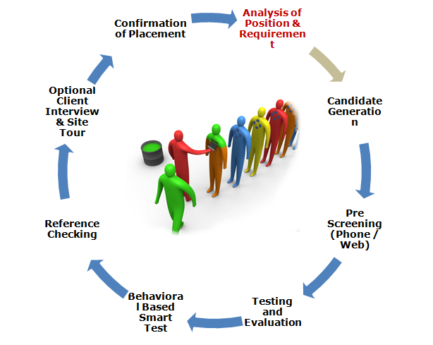

Head Office: D-3, 4th Floor Amir Chamber, Block-13A, Gulshan-e-Iqbal, Karachi, Sindh, Pakistan

Or, House-74/E, Block-E, Gulshan-e-Jamal Karachi Sindh

Telephone(s): (+92)-21-34688674, 34824210. Fax:021-34680660 Cell: (+92) 321-2374426

Web; [www.alhussaini.com.com](http://www.alhussaini.com.com) Email,ahcpvtltd@yahoo.com

Sub Office: Rawalpindi: House No:313, Street No-2, Munawar, Colony Adyala Road Rawalpindi Cell No-0300-2341043

Sub Office: SHARJAH- UAE: P.O Box; 64128, Sharjah UAE Cell No-0097156640024

***Introduction***

M/S Al-Hussaini & Company (Pvt) Ltd, understand the importance of human resource management and its influence on the successful operations of a company. It is not a secret that various corporations pay a lot of attention to the recruiting process and wellbeing of their employees, as people are the main asset in the business. Even though a company has a good strategy and sustainable funds, it will not reach success without loyal and well Recruited, Selected, Trained and Loyal human resources.



***Recruitment and Selection Process***

Recruitment and Selection process is defined as the process through which the best individuals are selected among a pool of applicants for particular positions of job. Mostly managers consider selection process as one of their critical decision functions in the organization. In selection process, the managers actually try to match knowledge, skills & abilities of the applicants with the requirements of the jobs. There is no single selection process that can be considered as standard one for all the organizations. Rather the steps & procedure of selection process varies from organization to organization.

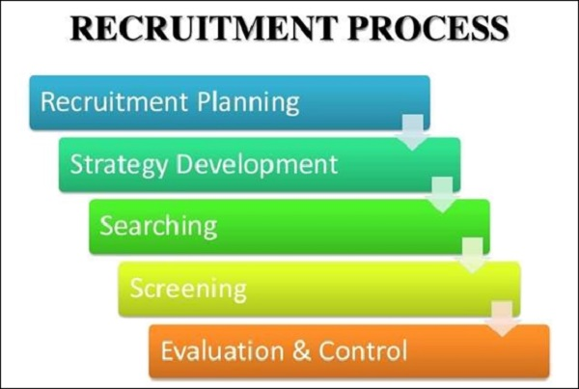

***Factors Effecting Recruitment and Selection Process***

[Recruitment and Selection Process](http://www.businessstudynotes.com/hrm/recruitment-and-selection-process-in-hrm/) is supported by a standard & permanent process of screening. However in some cases the screening process cannot simplify the selection process because there are certain other factors that influence the selection process. These factors are the environmental factors & are as follow:-

1. Legal Considerations
2. Speed of Decision Making
3. Organizational Hierarchy
4. Applicant Pool
5. Types of Organization
6. Probationary Period
7. Selection Criteria
8. **Legal Considerations**

[**Human Resource Management**](http://www.businessstudynotes.com/category/hrm/human-resource-management/) is influenced by the court decisions, executive orders & legislation. The management of the organization should use the legally defensive selection tools in the selection process.

1. **Speed of Decision Making**

The recruitment and selection process is directly influenced by the available time to make the decision of selection. In general cases the selection process is followed by the specified policies & procedures to protect the organization from legal issues. But in certain situations there is much pressure on the organization that leads the management to follow the exceptional selection process.

1. **Organizational Hierarchy**

Recruitment and selection process varies according to the filling posts of different levels of hierarchy in the organizational structure.

1. **Applicant Pool**

The recruitment and selection process is also influenced by the number of applicants for a particular job. In case of many qualified applicants for a particular post, the selection process becomes selective. For this purpose, selection ratio is ascertained by comparing the number of selected applicants to the number of applicants in a pool.

1. **Type of Organization**

The type of the organization like government organization, private or non-profit organization etc, also affects the selection process for the hiring individuals.

1. **Probationary Period**

Certain organization adopts the procedure of probation period in the selection process to check the potential of the individual on the basis of his performance. This may take the form of either validity check on the selection process or as a substitute of some steps of the selection process.

1. **Selection Criteria**

In most of the cases the applicants are selected on the basis of following factors or criterion:-

**Education**

**Competence**

**Experience**

**Skill & Ability**

**Personal Characteristics**

In way the applicant that best fits the above criterion is selected rather than the one that has extraordinary skills or over as well as under qualified because in such case the later selected person would not properly adjust in the organization.

### *****Steps Involved in Recruitment and Selection Process*****

In typical cases, the selection process starts with the preliminary interview after which the applications for the employment are filled by the candidates. The candidates pass through a number of selection tests, interviews of employment and background check & references. The candidates that are successful in all the previous steps get physical examination test by the company and if the results are satisfactory, they are selected. There are several internal & external forces that influence the selection process & therefore the managers must consider these factors before making a final decision of selection. Following are the standardized steps of the selection process but some organizations may alter some of these steps in their selection process.

* + Initial Screening
  + Application blank
  + Pre-employment Testing
  + Interview
  + Background Checks
  + Conditional Job Offer
  + Drug Test/Medical Exam
  + Final Selection Decision

Now each step is discussed one by one

* + 1. **Initial Screening**

Generally the Selectionand the Recruitment Process starts with the initial screening of applicants so that the unqualified ones are drop out at the initial stage. Initial screening is helpful to save the time, cost & effort of the selection committee in the following steps of the selection process. In this step certain general questions are asked from the applicants. There are chances that the some applicants would be unqualified for the job but some of them would be qualified. So the main purpose of screening of applicants is to reduce the number of applicants available in the selection process.

**Sources used in the Screening Effort**

The main source of initial screening is the curriculum vitae of the applicant along with the job application. Following information is included in the above mentioned documents.

* Education & employment History
* Evaluation of character
* Evaluation of job performance

**Screening Interviews**

Screening interviews are employed to:-

* To verify the accuracy & validity of the information given in the curriculum vitae of the applicant.
* The duration of these interviews is quite short.

**Advantages of Successful Screening**

When the initial screening step become successful, the removing applicants don not proceed to the next step of the selection process because they do not meet the minimum requirements. Secondly the selection costs of the organization are much reduced through proper screening of the applicants.

* + 1. **Application Blank**

The person’s application for employment is formally recorded in the shape of application blank. In the next step of the selection process, an application form for the employment is completed by the prospective applicant. The information contained in the application blank differ from one organization to another organization and in job posts, it may vary even within the same organization. But generally the informational needs and the requirements of EEO are covered in the application blank. The historical data from the candidate can be quickly collected through the application blanks so that further verification about the accuracy of the data is carried out.

* + 1. **Pre-employment Test**

The physical & mental abilities, knowledge, skills, personal characteristics & other aspects of behavior can be effectively measured through the pre-employment tests. For this purpose there are hundreds of test that can measure the different aspects of human behavior. With the passage of time, the application of pre-employment test is growing at a fast rate in the selection process because they can explain the qualities & skills of applicant clearly. These tests are more used in the large & public sector organizations.

The advantage of application of tests in the selection process is that it can ensure the potential & qualified candidate selection from a pool of applicants for a job.

**Characteristics of Well Designed Test**

A well designed selection test has the following characteristics:-

* Standardization
* Objectivity
* Norms
* Reliability
* Validity

**Kinds of Pre-employment Tests**

As individuals varies on the basis of cognitive abilities, job knowledge, vocational interests, psycho-motor abilities & personality etc. So, all these factors are measured through a set of different pre-employment tests which are as follow.

**Cognitive Aptitude tests**

In this test the ability to learn & perform a job by an individual is judged. The abilities related to job are as follow.

* Verbal
* Reasoning
* Numerical
* Perceptual Speed
* Spatial

**Psycho – motor Abilities Test**

In this test, the coordination, strength & dexterity of an individual is judged. Other abilities related to routine office jobs & production jobs can also be measured through these tests.

**Job knowledge Tests**

This test is used to measure the knowledge of the person about the duties of a particular job.

**Work Sample Tests**

A set of tasks that represent a job are identified in this test through which the productivity level, ability to face adverse conditions by the applicants are judged.

**Mechanical aptitude tests**

They measure the ability of a person to learn a particular type of mechanical work. These tests helps to measure specialized technical knowledge and problem solving abilities if the candidate. They are useful in selection of mechanics, maintenance workers, etc.

**Graphology Test**

It is designed to analyze the handwriting of individual. It has been said that an individual’s handwriting can suggest the degree of energy, inhibition and spontaneity, as well as disclose the idiosyncrasies and elements of balance and control. For example, big letters and emphasis on capital letters indicate a tendency towards domination and competitiveness. A slant to the right, moderate pressure and good legibility show leadership potential.

**Vocational Interest test**

This test identifies the occupations that are preferred by the candidate & that can provide him maximum satisfaction.

**Intelligence test**

This test helps to evaluate traits of intelligence. Mental ability, presence of mind (alertness), numerical ability, memory and such other aspects can be measured. The intelligence is probably the most widely administered standardized test in industry. It is taken to judge numerical, skills, reasoning, memory and such other abilities.

**Interest Test**

This is conducted to find out likes and dislikes of candidates towards occupations, hobbies, etc. such tests indicate which occupations are more in line with a person’s interest. Such tests also enable the company to provide vocational guidance to the selected candidates and even to the existing employees. These tests are used to measure an individual’s activity preferences. These tests are particularly useful for students considering many careers or employees deciding upon career changes.

**General knowledge Test**

Now days G.K. Tests are very common to find general awareness of the candidates in the field of sports, politics, world affairs, current affairs.

**Perception Test**

At times perception tests can be conducted to find out beliefs, attitudes, and mental sharpness etc.

**Personality Tests**

These tests are not considered to be so reliable & valid as compared to other pre-employment tests because these tests require external psychologist who interprets the results of the tests subjectively.

**Drug & Alcohol Tests**

For the security, productivity & safety of the workplace drug testing programs are used as pre-employment tests.

* + 1. **Job Interviews**

In the interview, the interviewer & applicant exchange information in order to achieve a goal through conversation. The employment interviews are conducted during the selection process through proper planning. The pleasant location of the interviewing place is selected and the interviewer has the good personality with empathy & ability to communicate & listen effectively. A job profile must be prepared on the basis of job description before conducting interview.

**Contents of the Interview**

Although the contents of the employment interview varies from one organization to another & also according to the nature of job but still following are the essential contents of the interview.

* Occupational Experience
* Academic Achievement
* Interpersonal Skills
* Personal Qualities
* Organizational Fit

**Types of Interviews**

The interviews are generally categorized into the following three types.

1. **Unstructured Interview**

In unstructured interviews open ended questions are asked from the applicant in order to perform probing. It is generally non-directive in nature and applicant is encouraged to give lengthy answers.

1. **Structured Interview**

In structured interview, a list of job related questions associated to particular job are asked from each applicant in a consistent manner. It is directive or patterned in nature and includes the following four kinds of questions.

* Situational Questions
* Job Knowledge Questions
* Job-sample simulation Questions
* Worker Requirement Questions

1. **Mixed Interview**

It is a special kind of structured interview in which specially designed questions are asked from the applicant to probe his past behavior in specific situations. It does not include the self-evaluative & hypothetical questions & inhibits to judge the personality of the applicant. The candidates are rated on the basis of their responses in the light of the bench-marked answer of successful employees.

**Methods of Interviewing**

Following are the main ways of conducting interviews:-

* + One-on-One Interview
  + Group Interview
  + Board Interview
  + Stress Interview
    1. **Back Ground Checks**

The accuracy of the application form of the candidate is verified through references & former employer. The educational, criminal record & legal status to work are verified. Personal references of applicant are contacted to confirm the validity & accuracy of the provided information. Effort is made to know the past behavior of the employees to that the future behavior can be predicted from it. Background checks assist the selection committee in dropping the applicants that have past insubordination issues, attendance problem, theft or special behavioral problems. The level of responsibility of the new job directs the intensity of the background investigation.

* + 1. **Conditional Job Offer**

After going through all the previous steps of selection process, there comes the most important step of the selection process in which the decision of hiring is made. The applicant that best meets the requirements of the job is selected. At start conditional job letter is issued which must be followed by medical exam.

* + 1. **Medical Examination**

When the conditional job letter is issued the next step of the selection process starts in which the physical/medical examination of the selected candidate is conducted. The medical exam of the candidate is essential to check either he takes the drugs or not. If he passes the exam, he would be finally selected for the job.

